Creating S3 bucket:

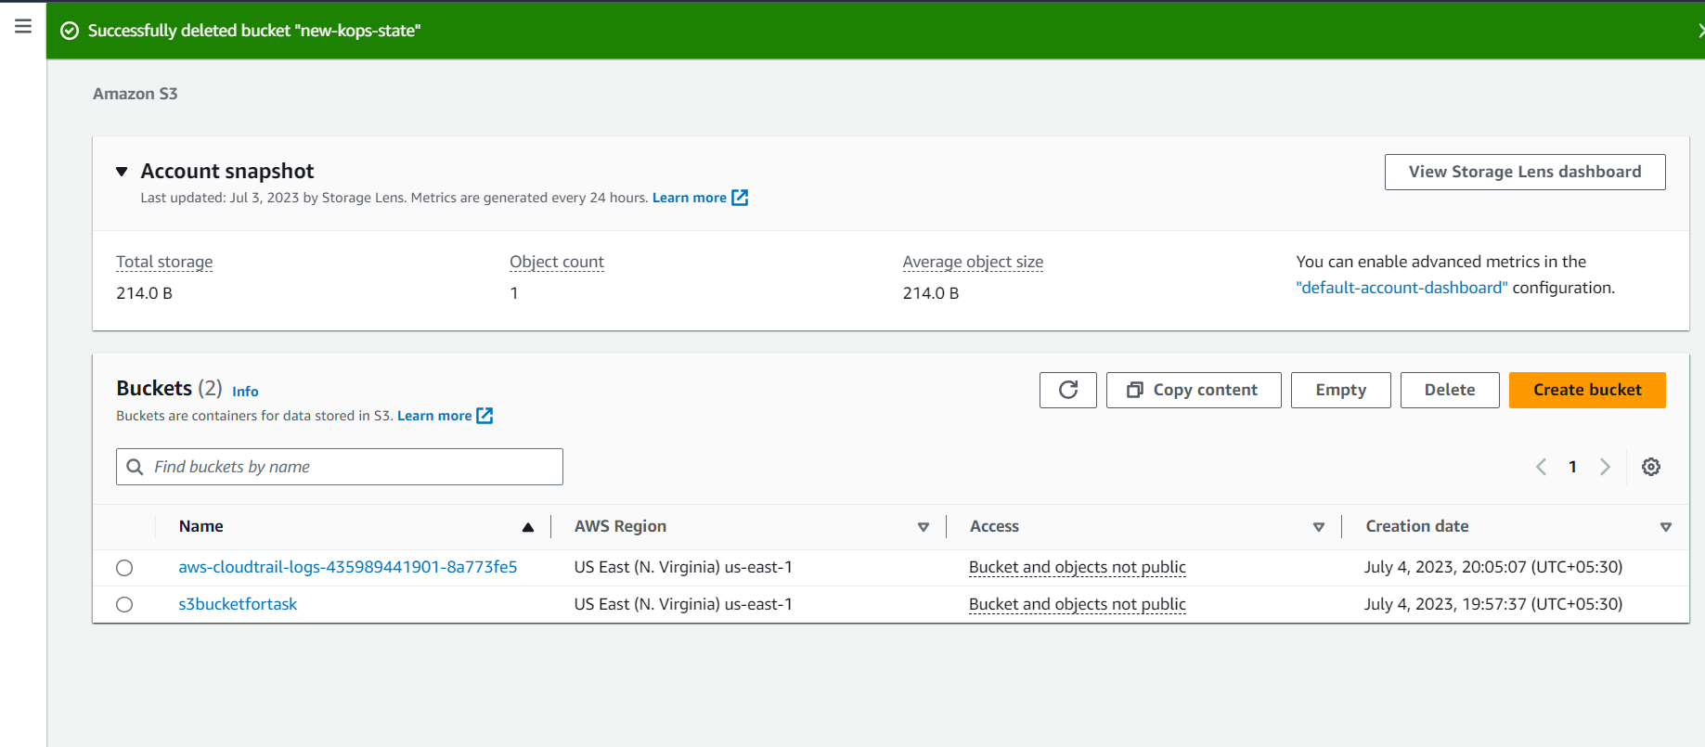

Creating Cloud Trail and mapping the created S3 bucket to capture the logs and events and also enabling cloudwatch log group

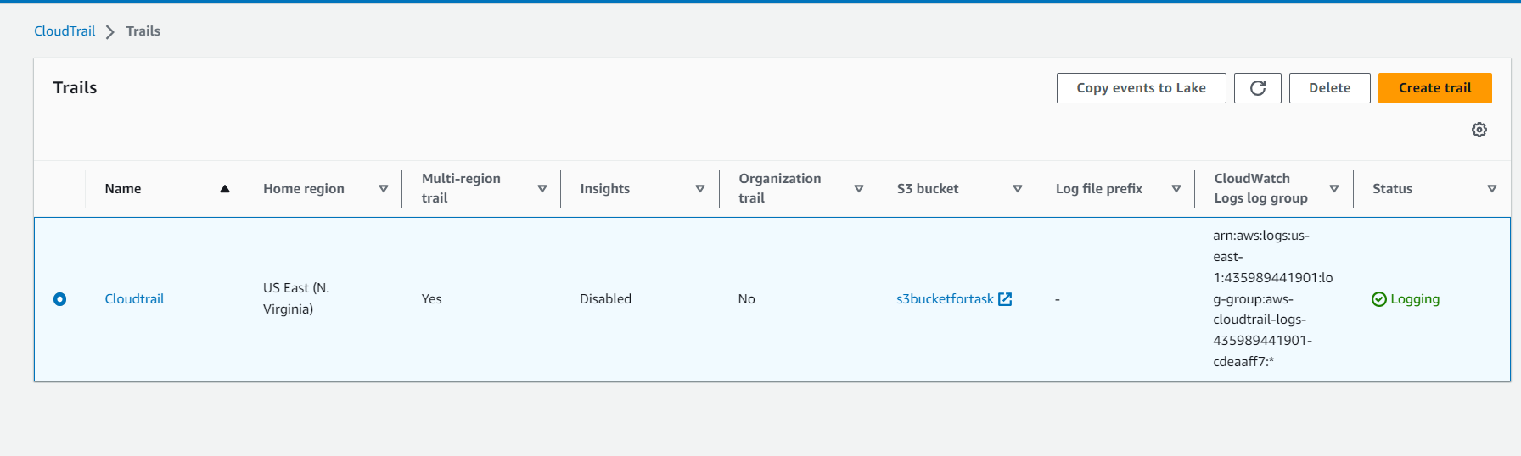

Cloudwatch log group

